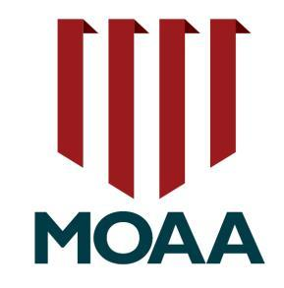
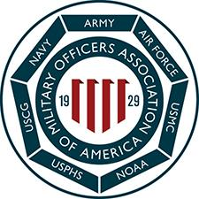
The Sandhills Chapter
of the
Military Officers Association of America
P. O. Box 4205
Pinehurst, North Carolina 28374
www.sandhillsmoaa.org

2 September 2026

To Our Past and Future Donors,

The Sandhills Chapter of the Military Officers Association of America (MOAA) is planning the
5th Annual Ralph Jacobson Memorial Veterans Putting Challenge to be held on November 9, 2026.
The event will be held at the Pinehurst Country Club, and the putting contest will be conducted on the
Thistle Dhu course.

The family of Ralph Jacobson has generously sponsored this event for the last four years. To make the 5th Ralph Jacobson event the most successful for our participating Veterans, I am requesting additional support from you for this important event, which is our sole fundraiser for the year. Your financial and other contributions help us in our mission to support Veterans in need in Moore County.

Your donation to this event supports our Veterans Support Fund (VSF) which funds urgent requests from Moore County Veterans; Veterans attending Sandhills Community College; Veterans receiving support from Habitat for Humanity; funding for our JROTC Scholarship Program that provides scholarships to deserving JROTC Cadets at Moore County High Schools.

Please circle the level of sponsorship you wish to support from the list below:

- Event/Corporate Sponsor $500
- Lunch Sponsor $300
- Scoreboard Sponsor $300
- Team/Hole Sponsor $150

As a Team Sponsor, your team or organization is entitled to field a 4-player team of veterans.
All sponsors will be recognized in pre-event and event promotions as well as in the field of play.

We invite you to become part of our MOAA community with a financial contribution or with a contribution of gift cards/certificates. If you are interested in donating or being a sponsor, please mail your donation to Sandhills MOAA, PO Box 4205, Pinehurst, NC 28374, or go to our website at www.sandhillsmoaa.org and click on the Veterans Support Fund link. When mailing a check please put
“VPC 2026” on the memo line.

Thank you in advance for considering our requests and supporting our veterans. Should you have any questions do not hesitate to contact me at president@sandhillsmoaa.org or (603) 320-0375.

Col Walt Havenstein, USMCR (RET), President
Sandhills Chapter, Military Officers Association of America

